April 20, 2012

NOGA WATTMETER METER LABEL INSTALLATION

Below is some information that might be helpful in installing the meters and putting on the calibration stickers. I don’t presume to offer either the best way or quickest way, but only one way to do it; possibly only to get you started from which you can develop your plan of attack. Read this through at least once to get a sense of what will be needed to be done. Before each step insert the word CAREFULLY if I have forgotten to.

Some pictures of the meter have been provided to help you in the disassembling of the meter and adding the new calibration sticker.

1. The size of the cutout for the meter movement is approximately 1 9/16” (39mm) by 7/8”(22mm). If you carefully enlarge the screw or mounting holes on the meter movement to 7/64”, a 4-40 screw can be used to mount the meter to your project box.

2. Before disassembling the meter to put on the new calibration sticker, clean the solder terminals around the holes on both sides by scraping with a knife, very fine grit sand paper, or steel wool. Lightly tin the meter solder terminals around the holes either now or just before you solder wire to the terminals.

3. Now we want to separate the two halves of the meter movement enclosure which is held together with tape. I’ve found that a razor blade works the best. Some of the taped areas are hard to see. If, after you have cut what you thought is all of the taped areas, you cannot pull the meter enclosure apart, then you probably have not cleanly cut all the tape. (Photo 3)

4. To prepare to attach the calibration stickers to the meters, cut the first calibration label to be attached as follows.

A. Horizontally, along the bottom border all the way across past the right side border to the end of the label.

B. Cut along the top edge of the label, horizontally, all the way across; leaving about a 1/16” white border above the black outline of the label (you want the height of the label to be high enough to cover the entire old calibration plate).

C. NOTE: At this time do not cut the end of the calibration tickers where the beige backing of the paper is exposed. Not cutting that end of the label will make it much easier to remove the calibration sticker from the paper backing. (Photo 4)

D. Cut the opposite side of the label (mentioned above) vertically along the vertical black border.

5. Now you are ready to attach the new calibration sticker to the old metal calibration scale. Peal the protective backing off the calibration sticker.

6. Hold the meter up horizontally with your left hand, on the left side of the case, leaving your forefinger free to push down on the new label when it is placed correctly on the old metal scale.

Position the meter movement where you can look straight into the pointer. Slide the new meter calibration label in behind the pointer to where the “0” on the new calibration label is directly behind the the meter pointer.

Then slowly press down on the calibration sticker with your forefinger on the left side of the pointer until the extreme left side of the calibration sticker sticks to the old metal calibration surface.

Next lay down, to the right of the pointer, the rest of the sticker up to the 3 watt marker.

IMPORTANT: Make sure that the label is lying totally flat with no ridges or wrinkles and that the bottom of the new label is horizontal and level with the bottom of the old metal calibration scale.

Check the alignment of the “0” marking and pointer and the levelness of the new calibration label across the meter. If too much of the new label protrudes below the old metal calibration scale, the pointer can catch and not move correctly across the scale. Press gently across all of the new calibration sticker to ensure it is secured well to the old metal calibration surface.

NOTE: These are not permanent labels so they can be detached and repositioned if necessary.

7. Now slide the clear plastic front meter housing on over the front of the meter and secure with a couple pieces of Scotch or similar tape. You are ready to mount the meter to your project box.

GOOD LUCK FROM ALL OF THE NOGANAUTS AT NoGa..!

THE NORTH GEORGIA QRP CLUB.

Photo 1
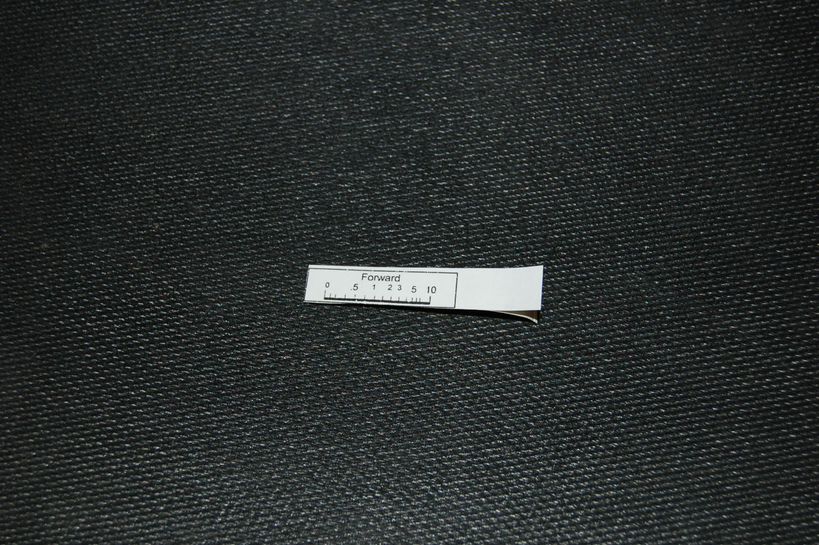

Photo 2
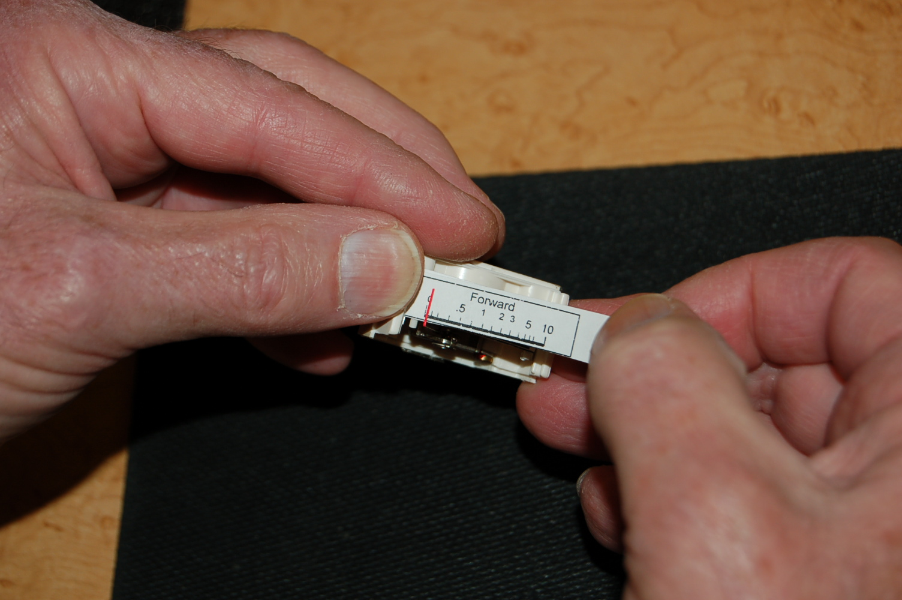

Photo 3
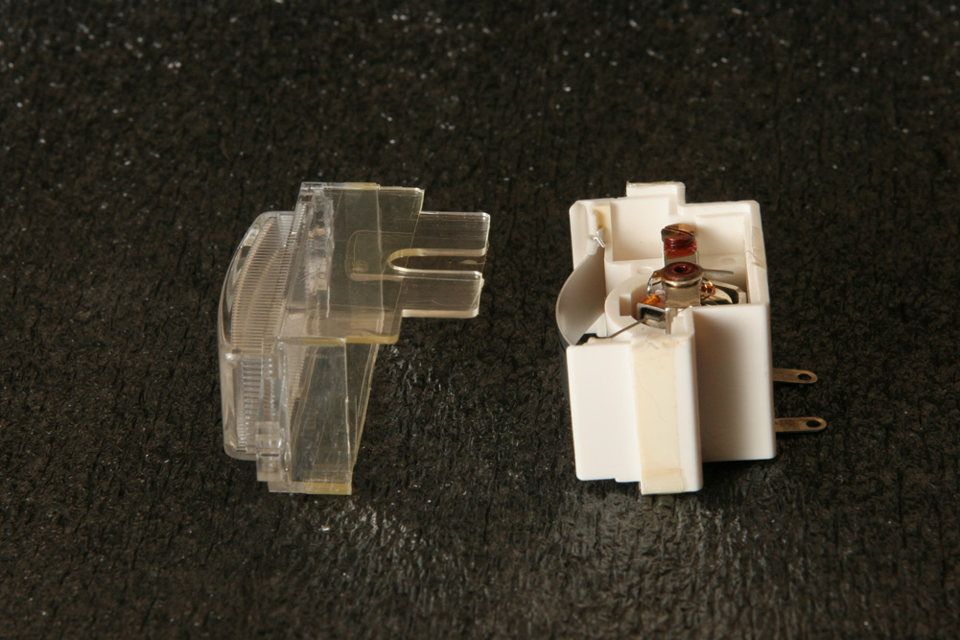

Photo 4
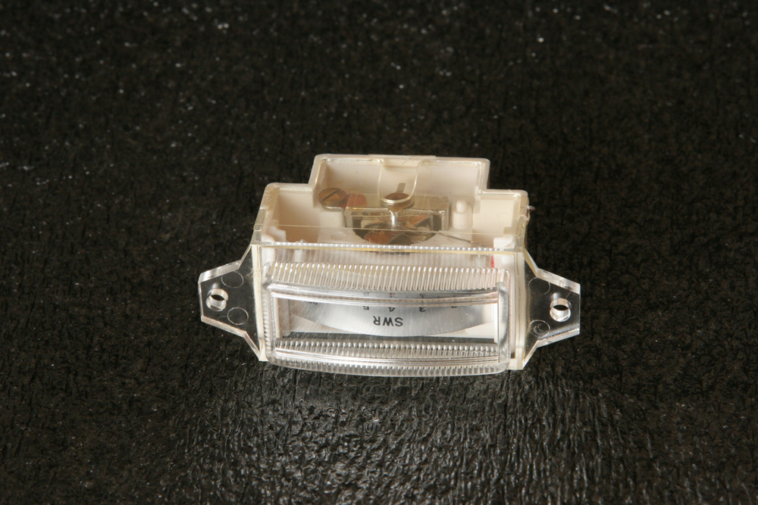

Right Click on any of the pictures to see a large picture..!
Photo5

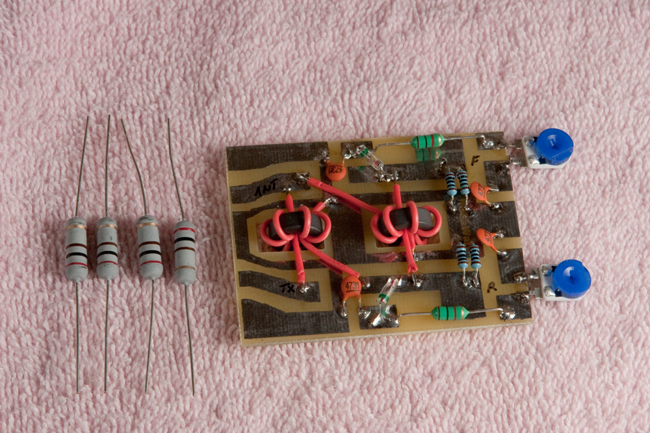

Photo 6
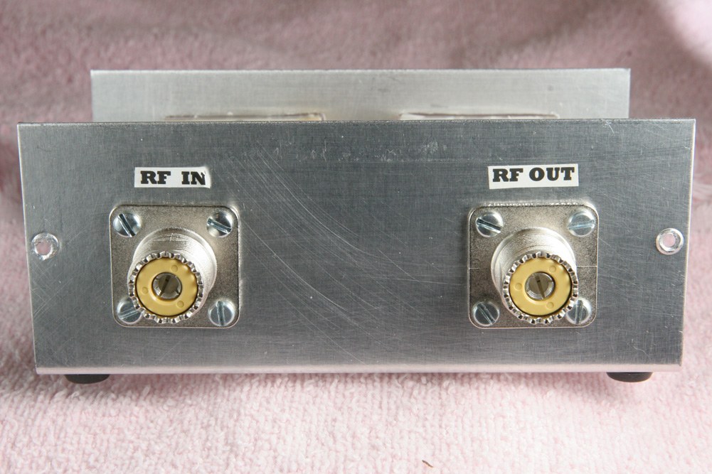

Photo 7
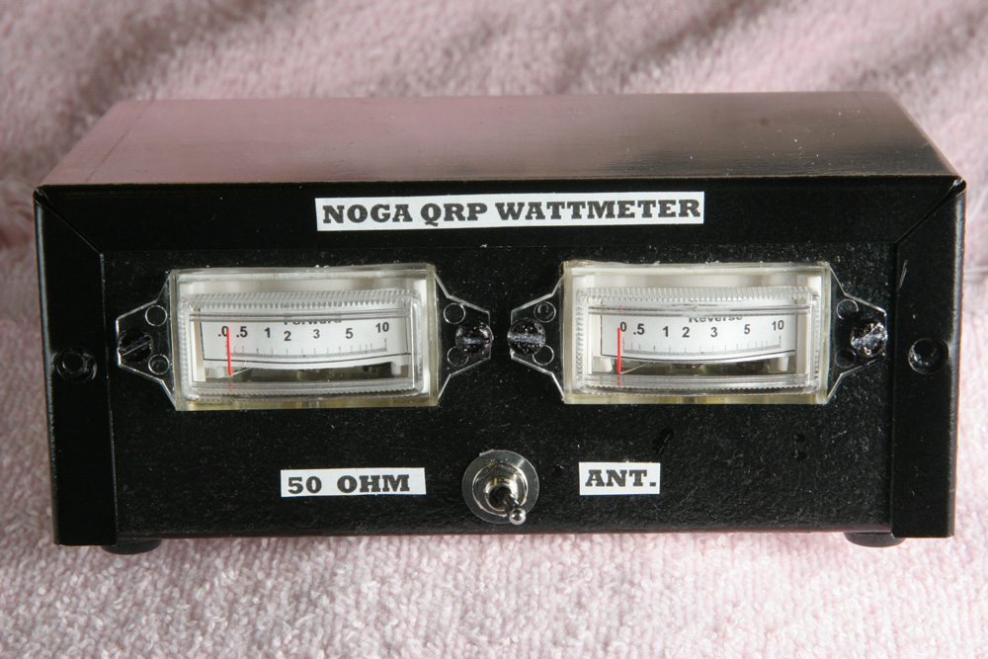

Photo 8
